**What is the problem?**

According to a study from The University of Oxford, Around 24% of all greenhouse gas emissions comes from food production. This is contributing to global warming.

There is a significant difference between the food items that leave a small environmental impact and the items that have the most damaging effect on the environment.

How can you, the consumer, easily make educated and environmentally friendly decisions while shopping everyday items in the grocery store?

<https://www.bbc.com/news/science-environment-46459714>

<https://ora.ox.ac.uk/objects/uuid:b0b53649-5e93-4415-bf07-6b0b1227172f>

<https://www.annualreviews.org/doi/full/10.1146/annurev-environ-020411-130608>

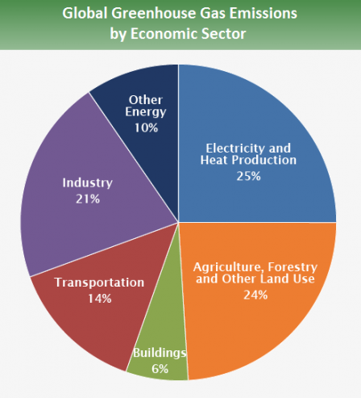

<https://www.epa.gov/ghgemissions/global-greenhouse-gas-emissions-data>

**Track your impact with MyImpact!**

With MyImpact close at hand in your phone, you can compare items in your grocery store to find out what impact they have made. This includes greenhouse gas emissions and social and ethical food labelling. You can also track your history on going green and follow your progress in the app.

There is also a possibility to share your high score with family, friends and all the other users of MyImpact to gain extra motivation on your journey.

According to our survey, over 77% of participants want to be more aware on how much impact their choices in the grocery store is causing.

In the same survey over 71% wanted to share their journey with family and friends in a type of competition on who is making the most environmentally friendly options in their everyday life.